Evaluation Report

*By Neil Rafferty (B00451753)*

December 2016

Lecturer: Dr Fiona Browne

Module: COM554 – Interactive Web Computing (Assignment 2)

Contents

Usability Test Result Table…………………………..………3

Usability Test Result Summary…………………….………..5

Response to Negative Issues…………………………………7

Usability Test Result Table

|  |  |  |  |
| --- | --- | --- | --- |
| **Question** | **Participant 1** | **Participant 2** | **Participant 3** |
| 1. Main page observations | Clicked on news article first.  Unlike other news site because of the number of horizontal items. | No ‘attention grabbing’ news article.  No Sports section. | Scrolled page first.  Expected headline article. |
| 2.View news items on Home tab? | Yes. | Yes. | Yes. |
| 3. Find descriptive overview of a news article? | Yes. | Yes. | Yes. |
| 4. Return from detailed overview to section? | Yes.  Tried browser back button first (didn't work). | Yes.  Tried esc and back button to exit the article (didn’t work). | Yes. |
| 5. Are all tabs clickable? | Yes. | Yes. | Yes,  Tried back button (didn’t work). |
| 6. Can you view the most popular articles? | Did not see the 'Most Popular' tab  (Looked for it on the main page).  Seen view counts. | Did not see the 'Most Popular' tab until later.  Seen view counts. | Yes. |
| 6a. Select article and view detail? | Yes. | Yes. | Yes. |
| 7. Access and comment on search help? | Did not see the tooltip helper. | Seen the tooltip but did not read it. | Seen the tooltip but did not read it. |
| 8. Perform a search? | Yes. | Yes | Yes. |

|  |  |  |  |
| --- | --- | --- | --- |
| **Question** | **Participant 1** | **Participant 2** | **Participant 3** |
| 9. Comments - unexpected screen behaviour? | Browser back button did not work for navigation. | Website seemed unresponsive at first (likely due to connectivity).  Enter Button Refreshing the page during search | Browser back button did not work for navigation. |
| 10. Comments - layout confusing or awkward? | No. | Confused due to non-clickable mouse pointer on clickable article. | Too many articles horizontally on main page. |
| 11. Comments - search unclear? | No. | User did not realise that the search was being run on every click. | No. |
| 12. Comments - appearance / layout issues? | No. | No. | The ‘News’ icon text should not appear to be clickable. |
| 13. Comments - changes suggested | Add more sections such as Northern Ireland and Scotland. | Make articles bigger  Add more sections such as sports.  Put headline News item at top. | Add magnifying glass icon to search bar.  Add functionality to navigate to page top.  Adding more sections such as local news. |
| 14. Comments - recommendations, anything else | No. | No. | No. |

Usability Test Result Summary

Each usability test was carried out in a controlled environment. The statement and questions were read word for word and no additional information was provided until after the tests. All tests were carried out on the ‘eb8d047’ master branch commit in the GitHub repository http://github.com/stormrage-neilr/COM_554_Assignement_2. The user interface used during the test is shown in figure 1. A recording was taken of each user during the tests and these were analysed to populate the usability test results table.

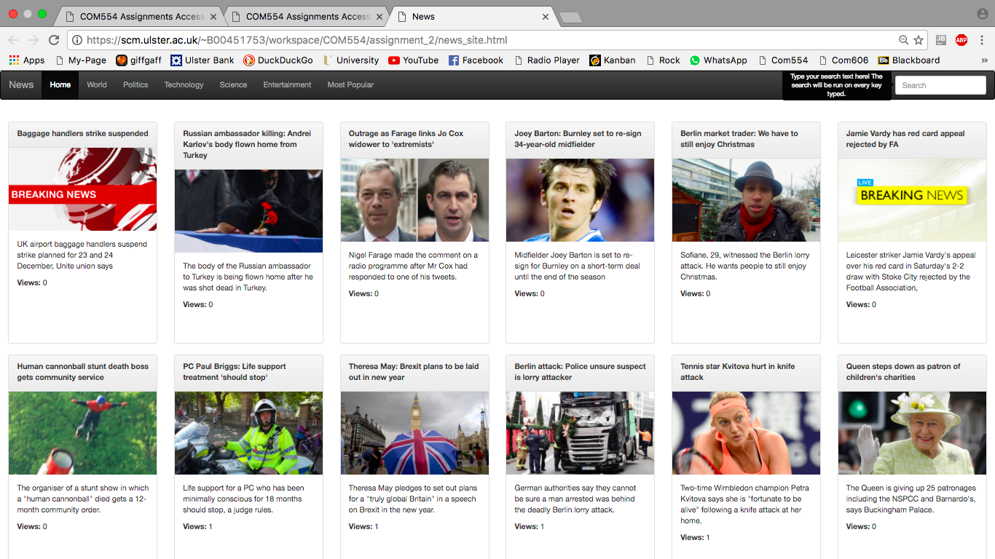

**Figure 1:** User Interface at the Time of the Usability Tests.

During the test, one participant lied about completing an action (this was due to confusion about the task at hand and possibly to prevent looking stupid or hurting feelings). For this reason, amongst others, the screen recordings proved to be extremely useful.

The tests revealed more issues than expected. The issues found were as follows:

* Each user tried to use the browsers’ back button at different stages to help navigate the site. This did not work as the application is a single view webpage.
* Two of the users could not find the most popular section in the navigation bar when first asked and instead looked for it in the main body of the site where they found the view counts (one user did not find the most popular section at all).
* A user did not see the search helper tool tip and the other users did not read it. One user, who found the tool tip, was surprised the search executes on every key entered even though the tool tip states this.
* A user pressed the enter key after typing their search query. This refreshed the page and, in doing so, navigated the user back to the home tab. This was not addressed during development as the search was being executed on each key press and the form submit button had been removed.
* A user was confused by the ‘News’ icon as it seemed clickable but did nothing when it was clicked.
* A user was confused when the incorrect mouse cursor was shown. This made a clickable item look like a non-clickable item.

User suggestions also proved to be extremely insightful:

* Every user suggested that a headline article should be added or fewer articles be placed at the top of the page as there was too many options.
* All users thought there should be more sections or subsections. One user suggested adding local news, another suggested adding multiple locations and the third suggested adding a sports section.
* One of the users suggested putting a magnifying glass icon beside the search box to help highlight it.
* The same user also suggested adding functionality to return to the top of the page after scrolling down.

The amount and variety of issues that have been raised during these tests has been eye opening. These issues would not have been found without the help of these participants and their fresh view of the application. This feedback has been used to improve the application.

Response to Negative Issues

Some of the negative issues raised during the usability tests have been addressed by taking the following actions:

* The HTML5 History API was used to link the user actions on the website to the browser back button, forward button and history. This was important because it was an issue experienced by all users. Subsequently, adding the history functionality fixed the refresh issue that occurred when the enter button was pressed after entering search criteria.
* The text of the tool tip was changed to further state that it is a search helper. This has made it larger, more visible and the description more detailed. Additional text was added to the main section of the web page when a search had been run. This should clear up any confusion about when the search has and has not been run.
* The confusion caused by the news brand element in the navigation bar highlighting on a hover event was also addressed. The cursor was changed to default when hovering over this element and the colour change of the font on a hover event was also removed. This makes the brand less interactive and more like the static element that it is.
* The cursor icon, when hovering over the panel header and view labels, was changed to a pointer to better reflect the interactivity of the news panels.

Some suggestions were also addressed before the project submission and the following changes were made:

* The number of horizontal articles on the webpage was reduced from six to four on a large sized screen.
* A magnifying glass bootstrap glyphicon was used to help highlight the search box.
* The navigation bar was fixed to the top of the screen so that the user does not have to scroll back to the top of the page to access it.

Given more time further issues would have been addressed by:

* Creating a carousel at the top of the page to display headline articles.
* Creating a side panel to host the most popular section instead of having it among the different news categories.
* More RSS feeds connections would have been used to create more sections for users (these sections would include Sports, Northern Ireland and possibly other locations).

Ideally, after all issues had been addressed, further usability tests would be carried out to verify the changes correctly fixed the underlying issues and did not cause any adverse effects.

Figure 2 shows how the website looks after these changes have been implemented. However, as many of these changes were small or back end changes they may not be easily distinguished from Figure 1.

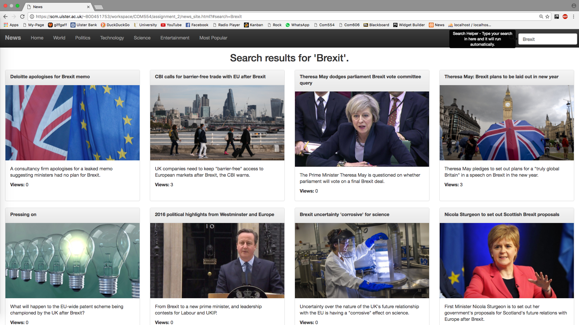**Figure 2:** User Interface After Addressing Some of the Issues.